Team Player Assignment

Table Creation

1. Team Table

create table team(

tid int primary key,

tname varchar(50),

player_num int check(player_num>0));

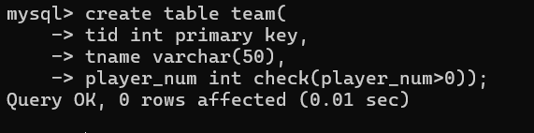

1. Player Table

create table player(

player_id int primary key,

pname varchar(20),

speciality enum('bowler','batsman','allrounder','wicket_keeper'),

date_of_joining date,

num_matches int,

team_id int,

constraint fk_tid foreign key(team_id) references team(tid)

on delete set null

on update cascade);

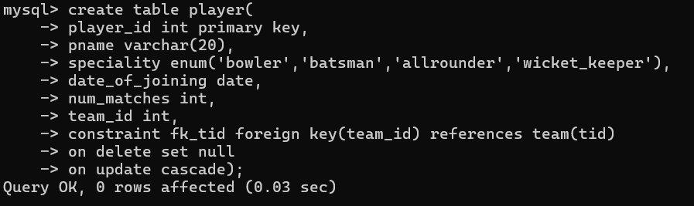

1. Matches Table

create table matches(

match_id int primary key,

team1 int,

team2 int,

match_date date,

winner int,

man_of_match int,

constraint fk_pid foreign key(man_of_match) references player(player_id),

constraint fk_team1 foreign key(team1) references team(tid) ,

constraint fk_team2 foreign key(team2) references team(tid) ,

constraint chk_win check(winner in (team1,team2)));

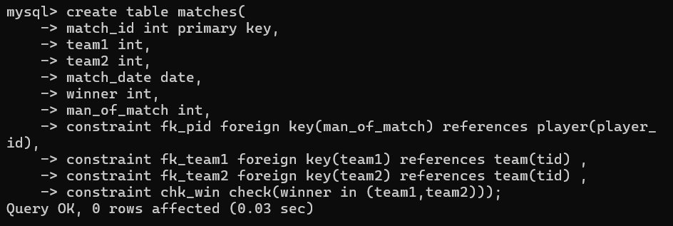

Inserting Values

1. Team Values

insert into team value(10,'CSK',15);



insert into team value(11,'RCB',13);

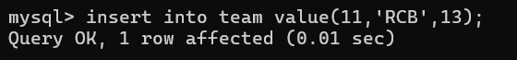

1. Player Values

insert into player values(7,'msd','wicket_keeper','2004-02-01',289,10);



insert into player values(18,'vk','batsman','2008-02-01',189,11);



insert into player values(8,'jadejja','allrounder','2006-10-01',199,10);



insert into player values(19,'kartik','wicket_keeper','2008-10-01',199,11);



1. Matches Values

insert into matches values(100,10,11,'2024-03-25',10,7);



insert into matches values(101,11,12,'2024-03-26',11,19);

Questions

1. display all players playerid, player name and experience

select player_id,pname,floor(datediff(curdate(),date_of_joining)/365) Experience from player;

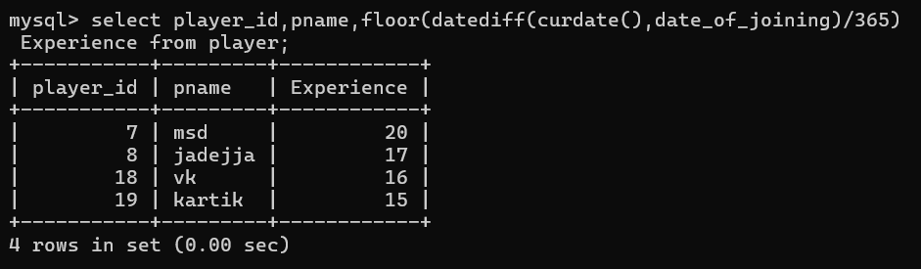

2. display all player with experience > 5 years

select player_id,pname,floor(datediff(curdate(),date_of_joining)/365) Experience

from player

having Experience>5;

OR

select player_id,pname,floor(datediff(curdate(),date_of_joining)/365) Experience

from player

having Experience>16;

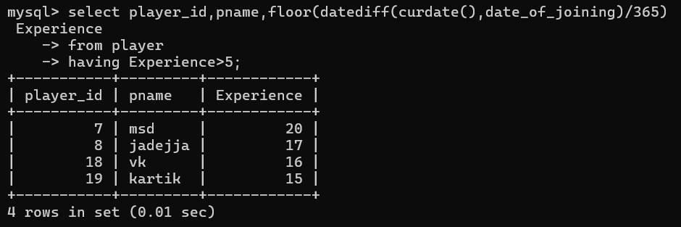

3. display all players joined in march month, any year

select * from player where monthname(date_of_joining)='March';



4. display all players joined in march 1995

select * from player where date_of_joining like '2004-03-__';



5. display all player with number of matches played are either 5 or 10 or 8

select * from player where num_matches in(5,10,8);



6. display all employees who are either batsman, bowler

select * from player where speciality in ('batsman');

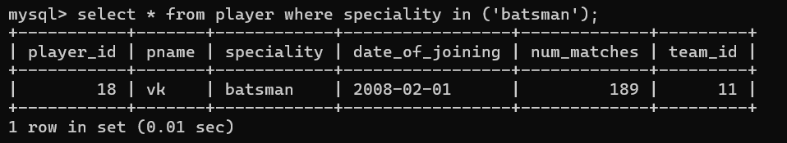

7. display all employees who joined in year 1995 or 1996 or 1997

select * from player where year(date_of_joining) in(2004,2006);

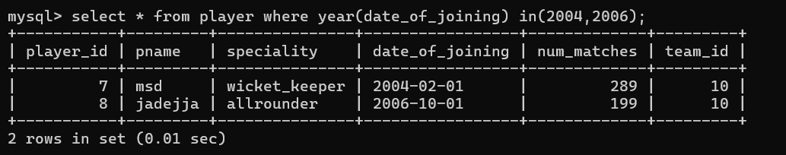

Nested Query

1. list all player who plays in virat kohalis team

select pname from player where team_id=(select team_id from player where pname='vk');

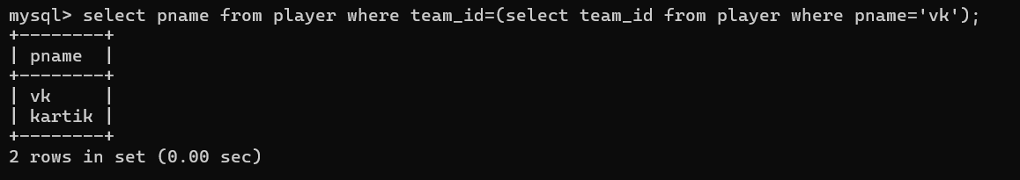

2. list all players who played matches in year 2024

select * from player where team_id in(select team1 from matches s where year(match_date)=2024) or team_id in(select team2 from matches s where year(match_date)=2024);

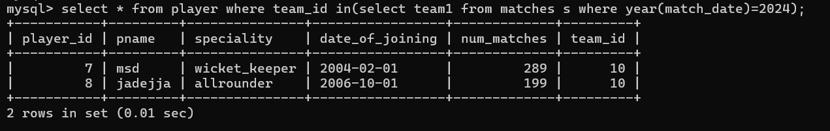

3. list all matches in which man of the match is from team1

select match_id,team1,man_of_match from matches m where team1=(select team_id from player p where m.man_of_match=p.player_id);

(Player 18 is not list because he is playing from team2)

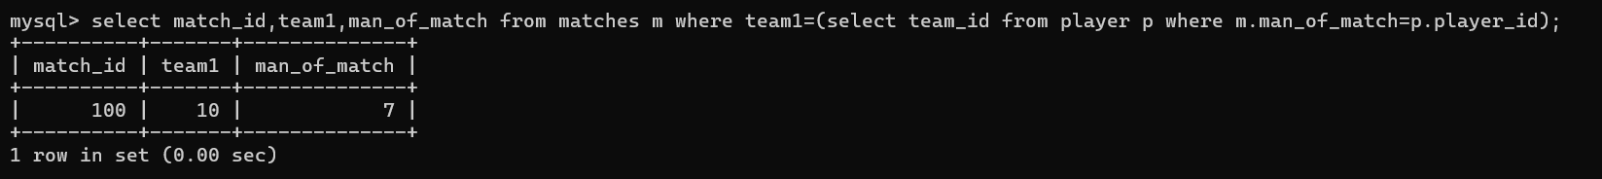

4. list all matches in which man of the match is from team2

select match_id,team2,man_of_match from matches m where team2 in(select team_id from player p where m.man_of_match=p.player_id);



5. list all matches in which csk team win.

select match_id,match_date,winner from matches where winner in(select tid from team where tname='CSK');

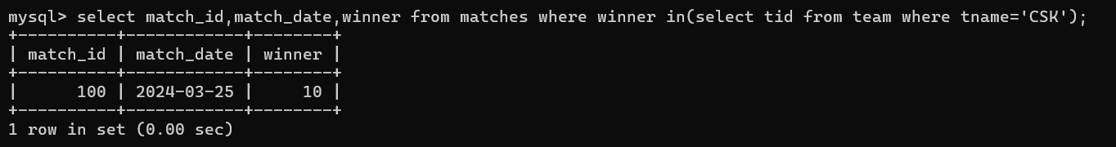

6. list all matches in which either csk or rcb team won the match

select match_id,match_date,winner from matches where winner in(select tid from team where tname in('CSK','RCB'));

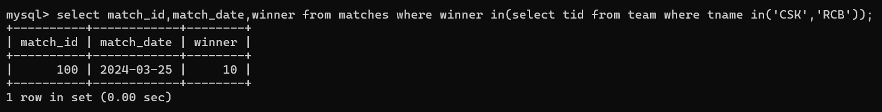

7. list all teams who one atleast one match

select tid,tname from team t where tid in(select winner from matches m where m.winner=t.tid);

OR

select tid,tname from team t where exists(select winner from matches m where m.winner=t.tid);

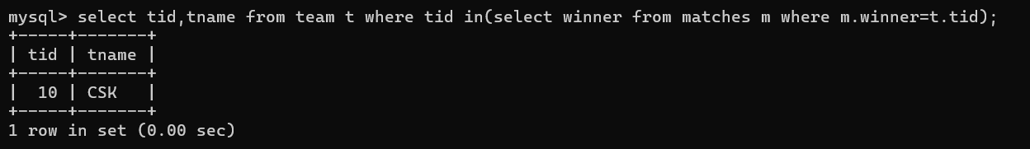

8. list all teams who does not played any match

select tid,tname from team t where not exists(select winner from matches m where m.winner=t.tid);

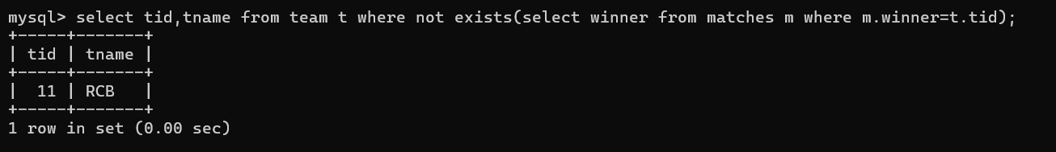

9. list all team name, in which no players are their

select * from team where player_num is null;

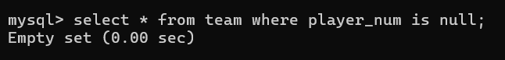

10. list all players who are in dhoni’s team

select pname from player where team_id in(select team_id from player where pname='MSD');

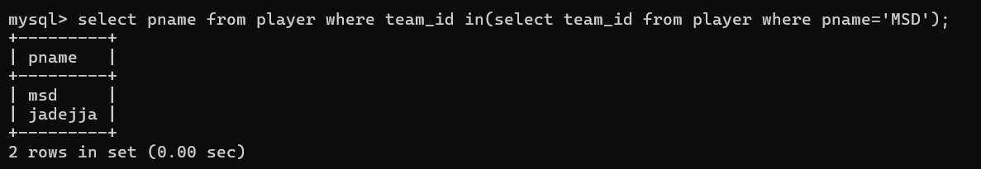

11. list all players who are in either dhoni’s or virat’s team

select pname from player where team_id in(select team_id from player where pname in('MSD','VK'));

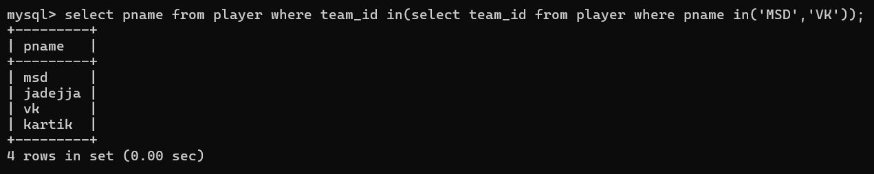

12. find all team names who one more than 3 matches

select tname from team where tid in (select winner from matches group by winner having count(*)>1);

